**Foraging efficiency of a generalist pantropical seabird, the Brown Booby *Sula leucogaster* (Boddaert, 1783)*,* in contrasting prey availability scenarios**

Victória Renata Fontoura Benemann¹*, Bianca Costa Ribeiro¹, Jessica Fernanda Hoffmann², Maria Virginia Petry¹

¹Laboratory of Ornithology and Marine Animals, University of Vale do Rio dos Sinos, Av. Unisinos, 950, São Leopoldo, RS 93022-000, Brazil.

²Technological Institute in Food for Health, University of Vale do Rio dos Sinos, 93022-750 São Leopoldo, RS, Brazil

*Corresponding author: [victoriabenemann@gmail.com](mailto:victoriabenemann@gmail.com)

**Abstract**

The Optimal Foraging Theory states that animals use different strategies to maximize energy intake by balancing energy gains and costs during foraging. For seabirds, high-quality prey rich in lipids and proteins enhances foraging efficiency, critical for reproduction and survival. On the other hand, prey choices may demand differential foraging efforts and energy expenditure to obtain feeding success. We integrated movement analysis (GPS, accelerometry, time-depth recorders) with dietary data (food load and prey energy density) to evaluate the foraging efficiency of brown boobies (*Sula leucogaster*) breeding in two Brazilian archipelagos with distinct scenarios of prey availability: Moleques do Sul (MS) and São Pedro e São Paulo (SPSP). We compared (1) prey composition, food load and energy density (kJ), (2) foraging effort metrics (maximum distance from colony, cumulative distance, trip duration and diving depth), and (3) energy expenditure and energy gain of chick-rearing brown boobies during three days between the archipelagos. We observed significant differences in protein content, lipids content, and food load energy density between sites, as well as in maximum distance from colony, diving depth, energy expenditure, and energy gain between the two colonies. We conclude that brown boobies from SPSP obtained a greater foraging efficiency than those from MS, which probably reflects differences in prey availability such as abundance, taxonomic composition and spatial distribution in the water column (benthic vs. epipelagic). Accelerometry and the calculation of Vectorial Dynamic Body Acceleration (VeDBA) are increasingly used to estimate the foraging energy costs of free-living animals, and when combined with dietary data it can provide precise information on foraging efficiency. Bioenergetic studies on foraging efficiency and feeding plasticity are crucial to understanding how seabirds adapt their diet and foraging strategies to fluctuations in prey availability and environmental challenges.

**Key-words:** Bioenergetics, accelerometers, VeDBA, macronutrient, energy density

**Introduction**

Optimal foraging theory (OFT) is a concept in ecology that focuses on explaining how animals choose their feeding habitats and resources to maximize their energy intake, usually measured by the energy gained per unit time from foraging, thus predicting the most profitable feeding strategy based on energy costs and gains during food foraging (MacArthur and Pianka, 1966). It states that the ratio between foraging effort and energy gain will determine whether the choice of a particular prey is favorable to the predator since the energy gain provided by the ingested resource must compensate for the energy expended in its capture and consumption, thus improving the foraging efficiency (Norberg, 1977). Foraging efficiency is the measure of how much food an animal gathers given the amount of energy it spends during that process, in a way that maximizes energy gain while minimizing energy expenditure (Mittelbach, 1981; Lescroël et al., 2010). It is often defined as the ratio of energy gained over energy spent while foraging and involves both the time spent searching for resources and the time spent processing or handling them (Weimerskirch et al., 2003). Efficiency is not only dependent on time but also on the energy costs associated with foraging movements, which are determined by the balance between the energy obtained from the resource and the energy expended during its searching and handling it (Elliott et al. 2009; Bennison et al., 2021; Sotillo et al., 2019; Sutton et al., 2023). Because predators may gather more with less effort, areas with abundant prey availability are typically more effective foraging grounds (Enstipp et al., 2007; Goundie et al., 2015; Waggitt et al., 2018).

The energy density and nutritional quality of prey play a crucial role in the foraging efficiency of seabirds, directly affecting their ability to meet energy demands to sustain long-distance foraging trips and to obtain breeding success (Wanless et al., 2005; Jodice et al., 2006; González-Medina et al., 2018). Prey rich in essential nutrients (e.g., lipids and proteins) enable seabirds to optimize calorie intake. Paradoxically, low-quality food resources may impose high energy costs and extended foraging time to fullfill the birds' nutritional demands, potentially decreasing overall foraging efficiency (González-Medina et al., 2018). Several studies demonstrate that the lipid:protein ratio represents the most important aspect in assessing the nutritional quality of a predator's diet, and that the consumption of prey with insufficient levels of these two nutrients can lead to losses in the fitness of reproductive adults and consequently in the reproductive success of populations, since a diet rich in proteins and lipids positively influences the weight gain and survival of nestlings of seabirds in the growth phase (Romano 1999, Anthony et al. 2000, Visser 2001; Sorensen et al. 2009). While a diet rich in lipids provides sufficient energy for the maintenance of adult individuals, and still with low metabolic costs when compared to protein, individuals in the growth phase require a greater demand of this second macronutrient for the synthesis of tissues at this stage of the life cycle (Roby et al., 1991; Anthony et al., 2000).

The junk-food hypothesis (Alverson, 1992) states that individuals consuming resources of low nutritional and energetic value tend to have reduced breeding success because dietary deficiencies affect the growth and cognitive abilities of offspring (Piatt and Anderson, 1996; Kitaysky et al., 2005; Wanless et al., 2005, Romano et al. 2006). Several studies suggest that fisheries discards represent a nutritionally poor food supply for seabirds. They often have low-calorie, protein, and lipid contents, and other essential nutrients that seabirds need for optimal health, growth, and reproduction (Grémmilet et al., 2008, Österblom et al., 2008). While discards may provide an easily accessible and often abundant food source in areas of intense fishing activity, requiring little foraging effort to catch, these discarded resources' nutritional quality can be inferior to seabirds' natural prey (Pichegru et al., 2007; Bicknell et al., 2013).

Fishery discards are non-target fish and other marine species, captured accidentally in fishing gears that do not meet commercial standards (e.g. undersized, underaged specimens) and thus are discarded by fishing vessels at sea (Bartumeus et al., 2010; Zeller et al., 2018; Sherley et al., 2019). Despite discards being an extra food resource, several studies show that these species are nutritionally poorer than natural prey (Grémillet et al., 2008; Bicknell et al., 2013), and do not compensate in terms of energetic gain (Pichegru et al., 2007; Le Bot et al., 2019). The importance of fishing discards as a food resource for seabirds is so great in certain locations that, for example, it is estimated that in the North Sea - one of the highest discard-producing regions in the world - discards are responsible for supporting more than 3 million seabirds by 2010 (Sherley et al., 2019).

The Brown Booby (*Sula leucogaster*) is a broadly distributed pantropical seabird species that exhibits a high level of trophic plasticity and can adapt its diet in response to the relative availability of prey, often considered a generalist species (Nunes et al., 2017; Jacoby et al., 2023). The interaction of this species with the trawling fleet, especially shrimp fishing, has been widely reported in several locations along the Brazilian coast (Branco, 2001; Branco et al., 2005; Carniel and Krull, 2012) and in other locations throughout its global geographic distribution (Blaber et al., 1995; Hill and Wassenberg, 2000, Cannell et al., 2022). Trawl fisheries produce the majority of global fishery discards worldwide. This occurs because trawl nets, which are dragged across the seafloor, often are made with a very fine mesh that captures great amounts of unwanted specimens, non-target species, and undersized and/or juvenile individuals (Gilman et al., 2020, Kennelly and Broadhurst, 2021; Barnes et al., 2022).

In the Moleques do Sul Archipelago (MS), Southern Brazil, 50% of brown boobies’ diet composition is attributed to derive from fishing discards (Branco, 2005). The species in this archipelago exhibit significant seasonal fluctuations in its diet, primarily due to the life cycle events of its prey and the availability of resources from fishery discards during specific periods of the year, particularly during the intensified shrimp fishing season in summer (Krul, 2004; Branco 2001; Branco et al., 2005). In São Pedro e São Paulo (SPSP), a tropical archipelago also in Brazil, brown boobies feed mostly on pelagic flying fish of the family Exocoetidae, exhibiting a much narrower trophic niche than in MS (Both and Freitas, 2001; Jacoby et al., 2023). *Exocoetus volitans* is a prevalent species, constituting 71% of its diet during the summer months (Naves et al., 2002), and is regarded as protein-rich prey (Harewood et al., 1993).

The marine landscape, oceanographic characteristics, and anthropic impacts on the archipelagos differ greatly. Moleques do Sul (27°51'S, 48°25'W) is a coastal archipelago located 14 km from the South American continent (Figure 1), which is under the continuous influence of the Brazilian Current, seasonally affected by the upwelling of cold waters from the Malvinas Current (Castro and Miranda, 1998), with intense fishing activity in the surrounding area. São Pedro e São Paulo (00°55'N, 29°20'W), on the other hand, is a pelagic archipelago located within an environmental protection area at 1,100 km from South America and 1,824 km from Africa and is inserted in the Equatorial System of Marine Currents, under the direct influence of the South-Equatorial Current and the submerged Equatorial Current (Costa Campos et al., 2005; Knoppers et al. 2009). The location, human activity and species composition reflected in the distinct composition of prey species in the boobies’ diet as well.

Recently, accelerometry data have been used to investigate the bioenergetics of free-ranging animals with greater precision (Bennison et al., 2021; Sutton et al., 2023). The most used technique to estimate energy expenditure from accelerometers is the calculation of vectorial dynamic body acceleration (VeDBA) due to its correlation with other traditional measures of energy expenditure such as quantifying the volume of oxygen utilized by muscles and heart rates (Laich et al., 2011; Gleiss et al., 2011; Qasem et al., 2012; Miuwa et al., 2015). These traditional methods are considered more invasive and therefore the use of accelerometry is increasingly encouraged (Wilson et al., 2020).

In this study, we combined the use of movement analysis (GPS, accelerometry, and time depth recorders) with dietary data (macronutrient composition) to assess the foraging efficiency of brown boobies breeding in two environmentally distinct archipelagos in Brazil, with contrasting scenarios of prey availability. Our main goals were (1) to compare the diet and nutritional composition and energy density of brown booby prey, (2) to compare foraging effort metrics (cumulative distance, maximum distance from colony, trip duration, diving depth, and energy expenditure) and (3) to compare the foraging efficiency (energy gain *vs.* energy expenditure) of brown boobies between the two archipelagos (MS and SPSP).

**Material and Methods**

***Field sampling***

We tagged 39 breeding brown boobies during chick-rearing period using Axy-Trek Marine loggers set to store 1 fix/10 s for three days. The Axy-Trek Marine (TechnoSmart, Italy) is a miniaturized data logger with an integrated GPS antenna, a tri-axial accelerometer, and a time depth recorder (TDR), specifically engineered for marine fauna. Logger's total mass was 11 g, equivalent to ~0.84% of brown boobies body weight. From the 39 sampled individuals, 19 were tracked in MS (10 females, 9 males) in September 2022, and 20 were tracked in SPSP (10 females, 10 males), in June 2022 (Figure 1). The loggers were attached using Tesa® tape to the three central tail feathers following Weimerskirch et al. (2005). Birds were captured using a hand net directly from the nest and measured (weight, bill length, wing length, tail length), ringed with numbered metal rings provided by CEMAVE, and then manually released back to their nest. Spontaneous regurgitations were obtained during birds’ handling, stored in plastic bags, and frozen until identification. This study was conducted under the approval of the Ethics Committee on Animal Use CEUA 14.2019 and the Research Authorizations IMA 31562-2022 and SISBIO 73286-4.

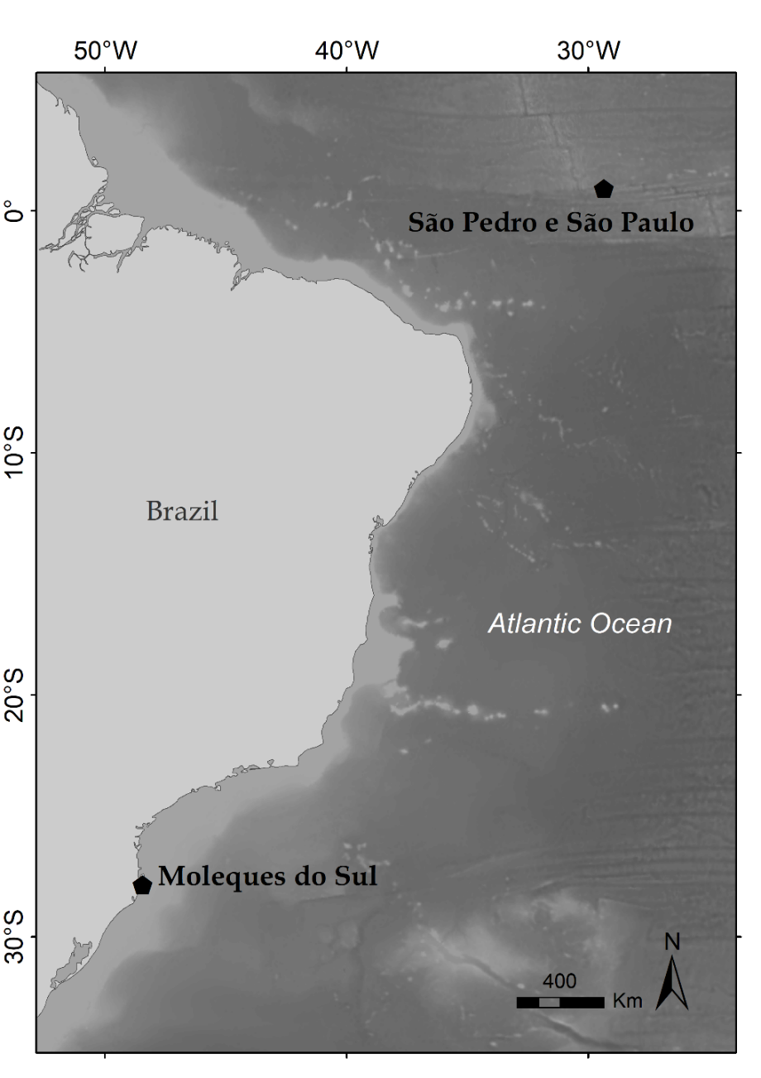

Figure 1: Location of Moleques do Sul and São Pedro e São Paulo Archipelagos, Brazil, where brown booby individuals were sampled.

***Diet and macronutrient determination***

Of the 39 individuals handled, we obtained 26 regurgitations: 14 from SPSP and 12 from MS. Diet samples were unfrozen, and then all prey specimens that were in a good state of conservation were identified at the species level using reference guides (Figueiredo and Menezes, 1997; Fischer et al., 2004), measured, and weighed. For the remaining 13 tracked individuals that did not regurgitate, we used an average of food load mass for their respective sex. To obtain nutritional information, we used a pool including prey specimens of each sample. The fish in the best conservation state were crushed whole in an electric grinder. Subsequently, this biomass corresponding to the food load of each brown booby sampled was analyzed to determine the protein, lipid and water content (%). We used the Kjeldahl method for protein determination and an adaptation of the Bligh-Dyer method for lipids determination (Lutz, 1985). The water percentage was determined by drying the sample in an oven at 105 °C until constant weight. Macronutrient analyses were performed in the Technological Institute of Food for Health (itt Nutrifor) of the Universidade do Vale do Rio dos Sinos. To estimate prey energy density (kJ g­­-¹) from macronutrient data, we followed the method used by Anthony et al. (2000), adapted from Schmidt-Nielsen (1997), through the following equation:

Where: WF is the water fraction, LF is the lipid fraction, and PF is the protein fraction of fish mass.

We then multiplied the energy density (kJ g­­-¹) of each sample by its total mass (g) to obtain the energy density of each food load (regurgitation).

***Movement analysis***

*Foraging trip metrics*

Utilizing R statistics within the track2KBA package (Beal et al., 2021), we derived the subsequent foraging trip metrics from the dataset: Maximum Distance from Colony (km), Cumulative Distance (km), and Trip Duration (hours) utilizing the 'tripSummary' function. *Maximum Distance from Colony (km)* refers to the straight-line distance from the deployment site within the colony nest to the furthest distant tracked location. *Cumulative Distance (km)* refers to the total distance traveled during a foraging trip. *Duration (hours)* refers to the interval from the initial sampling point at the commencement of a journey to the return time upon arrival at the colony. We employed the 'tripSplit' tool to eliminate points within 3 km of the colony, thereby identifying the beginning of foraging trips and excluding incomplete trips from the dataset. To process the diving information recorded by the TDR we used the diveMove R package (Luque, 2024). We extracted individual diving depths and calculated mean and maximum diving depths for each foraging trip (n = 182). A graphic of dives for each individual was plotted for visualization (Figure 6). We used the calculated trip metrics maximum distance from the colony (km), cumulative distance (km), trip duration (hours), mean and maximum diving depth (m) as proxies for foraging effort.

*Acceleration metrics*

VeDBA (Vectorial Dynamic Body Acceleration) is an emerging tool to estimate animals' energy expenditure from their movements and acceleration. This is a novel methodology in animal bioenergetics that enables the estimation of energy expenditure without the use of invasive methods, such as direct calorimetry or respirometry. VeDBA is calculated by summing the dynamic acceleration in the three directions - axes X (surge), Y (sway), and Z (heave) - resulting in a numeric value used as a proxy for energy expenditure. We calculated VeDBA from raw accelerometer data, only considering values collected within complete foraging trips (already filtered using the track2KBA package). Firstly, we calculated the average of each axis (X, Y, Z) to remove the static component of the acceleration, which is the gravitational acceleration. Then, we calculated VeDBA through the following equation:

VeDBA is a continuous value, and when it is equal to 0, it means that the animal is completely inactive, and then energy expenditure is zero. The higher the VeDBA value, the higher the energy expenditure is.

To estimate energy expenditure from accelerometers by converting VeDBA values to kilojoules (kJ), we followed the methods described by Bennison et al. (2021). This method assumes that the covariance between the rate of energy expenditure (kJ) and instantaneous VeDBA is linear, defined by slope *k*, which allows an estimate of kilojoules spent during that movement from a given VeDBA value. The process assumes that the amount of energy used during locomotion is equal to the animal's field metabolic rate (FMR) minus basal metabolic rate (BMR). The resulting value is defined as auxiliary energy expenditure (AEE), it is, the energy spent in a period of 24 hours by an animal only for movement. We obtained boobies’ FMR from the FMR calculator corrected for individual bird mass and colony latitude (Dunn et al. 2018), and BMR estimates through allometric equations proposed by Schreiber and Burger (2001) for sulids to transform VeDBA to kJ for each individual. We calculated VeDBA24 for each bird by summing VeDBA values for an entire day and then calculated a mean value for the three days, which was used in the prediction equation along with BMR and FMR estimations for the respective bird. By obtaining slopes *k* from the correlation VeDBA24 and AEE for each individual, we were able to estimate energy expenditure in kilojoules by multiplying *k* values by VeDBA24 values:

kJ = k * VeDBA

For more details on these calculations, see Bennison et al. (2021) and the Supplementary Material of this work. To evaluate the foraging efficiency, we calculated the final energy gain by subtracting food load energy density (kJ) from the energy expenditure (DBAkJ).

***Statistical analysis***

*Diet and macronutrient*

To test for significant differences in lipids (%), protein (%), energy density (kJ g­­-¹), and food load energy density (kJ) between archipelagos we used univariate tests (T-test and Mann-Whitney U) according to data distribution, after testing for normality and homogeneity of variances using Shapiro-Wilk and Levene’s test, respectively. The significance level was assumed at *p* < 0.05.

*Movement analysis*

We tested significant differences between archipelagos for the following parameters of foraging efficiency: maximum distance from colony, cumulative distance, trip duration, mean diving depth per foraging trip, energy expenditure (DBAkJ) and energy gain (food load energy density minus energy expenditure) between archipelagos using univariate tests (T-test and Wilcoxon rank-sum test) according to data distribution, after testing for normality and homogeneity of variances using Shapiro-Wilk and Levene’s test, respectively. The significance level was assumed at *p* < 0.05.

**Results**

*Diet and macronutrients*

We did not find any common prey species in the diet of the brown booby between the two archipelagos (Table 1). In MS, fish from the Scianidae family predominated, while in SPSP, fish from the Exocoetidae family predominated, both in abundance and biomass. The food load biomass was higher in SPSP (x̅ = 163.65, σ = 83.6) than in MS (x̅ = 98.61, σ = 33.39). We found a significant difference in the prey protein (t = -4.7995, df = 24, p < 0.05) and lipids (W = 124, p < 0.05) percentage between the archipelagos, where the protein fraction was higher in prey from SPSP and lipids in prey from MS (Figure 2). No significant difference was found when comparing the proportional energy density (kJ/g-1) between prey from the two archipelagos (t = 1.6756, df = 24, p > 0.05), but when we considered the energy density of the total food load (kJ), a significant difference was found (t = -2.8809, df = 17.644, p < 0,05), where food loads from SPSP were more energetic (Figure 2). Mean and standard deviation of each nutritional parameter evaluated are expressed in Table 2.

Table 1: Prey species found in the brown booby diet in the archipelagos of Moleques do Sul and São Pedro e São Paulo.

|  |  |  |
| --- | --- | --- |
|  | Abundance | Total biomass (g) |
|  | Moleques do Sul (n = 12) | |
| **Osteichthyes** |  |  |
| Engraulidae |  |  |
| *Cetengraulis edentulus* | 3 | 66.82 |
| Scianidae |  |  |
| *Paralonchurus brasiliensis* | 2 | 103.88 |
| *Larimus breviceps* | 2 | 45.89 |
| *Cynoscion guatucupa* | 4 | 159.91 |
| *Isopisthus parvipinnis* | 4 | 170.31 |
| Mullidae |  |  |
| *Mullus argentinae* | 3 | 63.14 |
| Priacanthidae |  |  |
| *Priacanthus arenatus* | 2 | 129.15 |
| Unidentified prey |  | 753.11 |
|  | São Pedro e São Paulo (n = 14) | |
| **Osteichthyes** |  |  |
| Exocoetidae |  |  |
| *Cheilopogon cyanopterus* | 7 | 1790.83 |
| *Exocoetus volitans* | 32 | 2429.91 |
| *Hemiramphus balao* | 1 | 7.52 |
| *Hirundichthys affinis* | 1 | 36.69 |
| *Oxyporhamphus micropterus* | 11 | 1880.94 |
| *Prognichthys gibbifrons* | 3 | 560.93 |
| Scrombidae |  |  |
| *Scomberomorus cavalla* | 1 | 11.57 |
| **Cephalopoda** |  |  |
| Unidentified sp. | 1 | 8.17 |
| Unidentified prey | 33 | 2570.51 |

Table 2: Mean and standard deviation of nutritional parameters of brown booby prey. Asterisks mean significant difference between archipelagos.

|  |  |  |  |  |  |  |  |
| --- | --- | --- | --- | --- | --- | --- | --- |
|  | **Moleques do Sul (n = 12)** | |  | **São Pedro e São Paulo (n = 14)** | |  | **Statistics** |
|  | Mean | SD |  | Mean | SD |  |  |
| Protein (%) | 16.44 | 2.90 |  | 21.19 | 2.23 |  | t = -4.7995, p < 0.05*** |
| Lipids (%) | 7.96 | 4.10 |  | 4.88 | 2.11 |  | W = 124, p < 0.05*** |
| Energy density (kJ g-1) | 4.67 | 1.27 |  | 4.13 | 0.75 |  | t = 1.6756, p > 0.05 |
| Food load energy density (kJ) | 429.42 | 173.08 |  | 736.21 | 405.00 |  | t = -2.8809, p < 0,05*** |

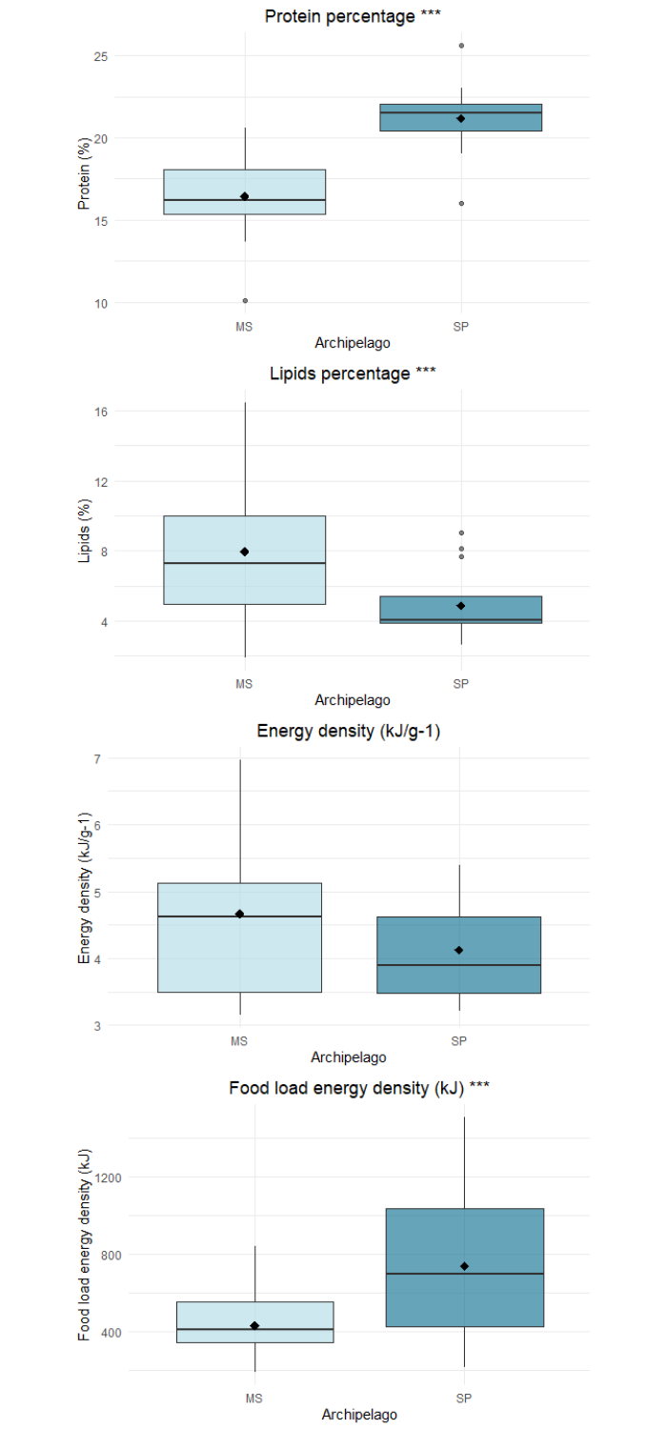

Figure 2: Differences in macronutrient composition (protein percentage, lipid percentage, energy density (kJ/g-1) and food load energy density (kJ) of brown booby prey between the two studies archipelagos. Asterisks (***) represent significant differences at the significance level p < 0,05.

*Movement analysis*

Foraging trip metrics were, in general, similar between the archipelagos (Table 3, Figure 3), with exception for maximum distance from colony and diving depth. Brown boobies from MS performed significantly farther trips (W = 5017, p < 0.05), reaching a maximum distance of 86.9 km from the colony (Figure 4). In comparison, in SPSP the maximum distance reached was 45.3 km. Mean and maximum diving depth also varied significantly (t = 2.2365, p < 0.05 and W = 4881.5, p < 0.05, respectively), where individuals from MS dived deeper in both metrics (Figures 4 and 6). The median trip duration was equal between archipelagos: 2.1 hours. The maximum cumulative distance was also higher in MS than in SPSP (103.5 and 87, respectively), but not at a statistically significant level.

Table 3: Foraging trip metrics of brown boobies in the archipelagos of Moleques do Sul (MS) and São Pedro e São Paulo (SPSP). Results for metrics are given as median [Q1-Q3] with range (min-max) in parenthesis.

|  |  |  |  |
| --- | --- | --- | --- |
| **Foraging trip metric** | **MS (n = 19)** | **SPSP (n = 20)** | **Statistics** |
| Total number of trips | 45 | 37 |  |
| Trip duration (h) | 2.2 [1 – 3] (1 – 7.4) | 2 [1 – 3] (1 – 5.9) | W = 910, p = 0.4751 |
| Maximum distance (km) | 29.9 [21 – 34] (14.6 – 86.9) | 22.8 [18 – 47] (7.4 – 47.6) | W = 1156, p = 0.0002* |
| Cumulative distance (km) | 83.2 [51 – 127] (37.4 – 232.2) | 62.8 [47 – 94] (27 - 161) | W = 1006, p = 0.1072 |
| Mean diving depth (m) | 2.01 [1.4 - 2.4] (0.5 - 3.1) | 1.85 [1.6 - 2] (0.5 - 2.4) | t = 2.2365, df = 117.15, p < 0.05* |
| Maximum diving depth (m) | 3.02 [2.2 - 13.5] (0.8 - 29.5) | 2.62 [2.1 - 6.2] (1.2 - 17.8) | W = 4881.5, p < 0.05* |

Figure 3: Differences in foraging trip metrics (maximum distance from colony, cumulative distance, and trip duration of brown boobies between the two studied archipelagos. Asterisks (***) represent significant differences at the significance level p < 0,05.

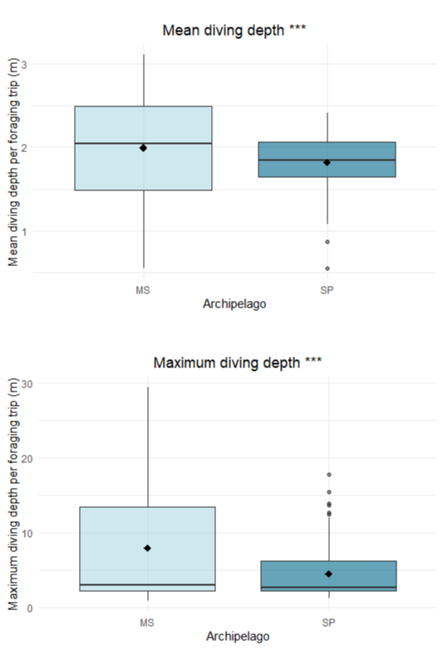

Figure 4: Differences in mean and maximum diving depths reached by brown boobies during foraging trips between the two studied archipelagos. Asterisks (***) represent significant differences at the significance level p < 0,05.

Figure 5: Foraging trips of brown boobies tracked for three days in the Moleques do Sul archipelago (n = 19, September 2022) and São Pedro e São Paulo archipelago (n = 20, June 2022).

Figure 6: Individual diving depths reached by brown in Moleques do Sul (n = 19, September 2022) and São Pedro e São Paulo (n = 20, June 2022) archipelagos.

*Foraging efficiency*

A significant difference was found in the daily energy expenditure (kJ) of brown boobies during foraging trips between the two archipelagos (W = 166, p < 0.05), where brown boobies from MS spend much more energy on foraging than SPSP individuals. The foraging efficiency (energy gain – energy expenditure) was also significantly higher in SPSP (t = -7.0349, df = 18.867, p < 0.05) (Figure 5).

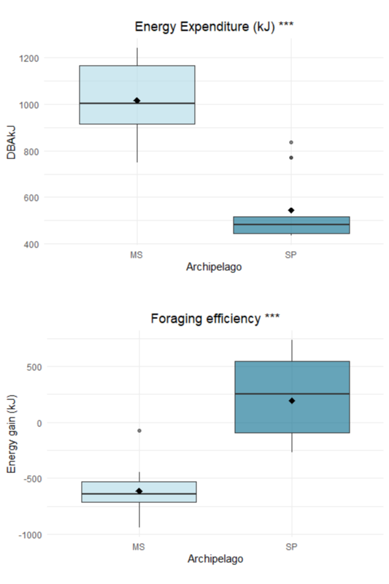

Figure 7: Differences in daily energy expenditure and foraging efficiency of brown boobies between the two studies archipelagos. Asterisks (***) represent significant differences at the significance level p < 0,05

**Discussion**

The nutritional quality of prey and the energy expended during foraging are important factors in evaluating foraging efficiency in seabirds and play a crucial role in seabird survival and breeding success, especially in challenging environments (Romano 1999, Jodice et al. 2006, González-Medina et al. 2018, Sorensen et al. 2019). We investigated the foraging efficiency of breeding Brown boobies on two oceanic islands with distinct locations, environmental and human pressure characteristics. We found significant differences in prey species, dietary parameters (protein percentage, lipid percentage, and food load energy density), and movement parameters (maximum distance from the colony, diving depth and energy expenditure) of the breeding Brown boobies in SPSP and MS. On the other hand, no significant differences were observed between the archipelagos in cumulative distance traveled, trip duration, or overall foraging efficiency.

*Diet and macronutrients*

The boobies from both archipelagos feed on completely different prey species. In MS, the birds primarily fed on fish from the Sciaenidae family (such as croakers, *Paralonchurus brasiliensis*), while in SPSP, they mainly consumed species from the Exocoetidae family (flying fish). Our results on the taxonomic composition of brown booby prey in MS and SPSP are in accordance with previous studies (Naves et al., 2002; Branco et al., 2005; Mancini and Bugoni, 2014; Jacoby et al., 2023). The absence of shared prey species between MS and SPSP likely reflects the geography of these islands, distinct oceanographic conditions, and differences in local human pressures. MS is located on the continental shelf and constitutes a subtropical neritic ecosystem. Neritic environments are coastal marine areas that are typically shallow and extend from the low tide mark to the edge of the continental shelf, and are considered highly productive areas (Araújo et al., 2018; Macedo et al., 2021). SPSP archipelago is inserted in an oceanic ecosystem, where the distribution of high primary productivity patches is more heterogeneous and influenced by several oceanographic patterns such as ocean circulation, convergence zones and small- scale upwellings (Soares et al., 2002; Nunes et al., 2017). The role of fishery-related prey in MS may also be highlighted. Moleques do Sul is an archipelago near the southern coast of Brazil with intense shrimp fishing activity, particularly during late spring and summer (Haimovici et al., 1996; Haimovici and Mendonça, 1996). São Pedro and São Paulo, on the other hand, is a marine protected area where fishing activity is regulated and supervised by the Brazilian Navy within a radius of 200 nautical miles around the archipelago, when any form of predatory fishing is prohibited, thus ensuring ecological balance in the ecosystem (Brasil, 2018).

Considering the difference in the taxonomic composition of brown booby prey between MS and SPSP, it was expected that lipids and protein composition of prey would also vary between the two archipelagos. Prey from MS exhibited higher lipid content, while prey from SPSP showed a higher protein content. Both lipids and proteins have significant ecological implications for measuring the energy density and nutritional quality of prey, directly influencing ecological aspects of seabirds, such as fitness (Anthony et al., 2000; Sorensen et al., 2009; Albano et al., 2011). Lipids, for example, are considered an important component of prey nutritional quality for seabirds, as they provide a dense and efficient energy source during periods of high demand, such as movement, breeding, or molting (Anthony et al., 2000; Romano et al., 2006; Seaman et al., 2005; Lamb et al., 2017; González-Medina et al., 2018). The lipid content was significantly higher in prey from MS (x̅ = 7.96, σ = 4.1) compared to prey from SPSP (x̅ = 4.88, σ = 2.11), and the mean energy density was 4.67 kJ g-1 for MS prey (mostly Scianidae) and 4.13 kJ g-1 for SPSP prey (mostly Exocoetidae). The protein content, on the other hand, was significantly higher in SPSP prey (x̅ = 21.19, σ = 2.23) than in MS (x̅ = 16.44, σ = 2.9). The role of protein content in seabirds’ health is poorly studied, and most studies regarding the nutritional quality of diet only address the percentage of protein only to calculate energy density, without discussing the direct effects of this nutrient on seabirds’ health, growth and breeding success (Wanless et al., 2005; Jodice et al., 2006, Lamb et al., 2017, Miller et al., 2018). Protein reserves are especially important when individuals reach their minimum critical body mass due to feeding restrictions when they begin to use protein rather than fat reserves (Weimerskirch et al. 2003).

Shifts in the nutritional quality and availability of local prey can disrupt marine ecosystems and affect predator populations (Wanless et al., 2005). On the west coast of South Africa, for example, a decline in the Cape gannet (*Morus capensis*) population was attributed to reduced availability of lipid-rich fish prey such as anchovy (*Engraulis encrasicolus*) and sardine (*Sardinops sagax*) (Mullers et al., 2009). In that study, fish discarded by fisheries (*Merluccius* sp.) had a lower energy content (4.07 kJ/g-1) and fat content (2.5%) than anchovy (6.74 kJ/g-1 and 4.2%) and sardines (8.59 kJ/g-1 and 4.8%). These findings highlight how variations in prey quality, as observed in our study, can influence predator populations by affecting their energy intake and overall fitness. Although the prey from MS (mainly croakers and other Sciaenidae species) showed higher fat values than the prey from SPSP (flying fish), we emphasize that these results should be interpreted with caution, as optimal foraging is evaluated based on the balance between foraging effort and energy gain. In other words, although birds from SPSP consume prey with lower lipid values, this outcome must be assessed alongside the food load mass, the effort expended during foraging activity, and the positive energy balance achieved.

*Energy density x Food Load Energy Density*

The total food load energy density was significantly higher in SPSP (736.21 kJ) compared to MS (429.42 kJ), despite prey from MS exhibiting a greater proportional energy density (4.67 kJ g⁻¹) than prey from SPSP (4.13 kJ g⁻¹). This difference can be attributed to the larger food load biomass observed in SPSP (x̅ = 163.65 g, σ = 83.6) compared to MS (x̅ = 98.61 g, σ = 33.39). The higher food load energy density in SPSP indicates that prey abundance may compensate for the lower proportional energy density. This can suggest that the foraging strategy of brown boobies in SPSP is shaped by the availability of protein-rich prey, allowing them to gather sufficient energy through larger food loads. In contrast, the higher proportional energy density of MS prey reflects a reliance on lipid-rich prey, which provides efficient energy for adult metabolic demands but is delivered in smaller quantities due to lower prey abundance. The low food load regurgitated by brown boobies during this study is in accordance with the results found by Branco et al. 2005, who reported a seasonal fluctuation in regurgitations biomass with lower values during spring and autumn compared with summer and winter. Our sampling was conducted in September (early spring) when trawl fishing effort is lower on the coast of Santa Catarina, being more intense during late spring and summer (Haimovici et al., 1996; Haimovici and Mendonça, 1996). It is possible that during periods of intense trawl fishing the prey availability for brown boobies increases, as well as the foraging effort decreases, since it is known that the species feeds intensely on fishing discards in the region (Branco, 2001; Branco et al., 2005).

This trade-off between prey quality and quantity highlights how local ecological conditions influence foraging strategies and energy intake. From a fitness perspective, the greater food load energy density in SPSP could confer advantages during the chick-rearing period, ensuring that sufficient energy is delivered to support offspring growth (Wanless et al., 2005; Romano et al., 2006; Albano et al., 2011; González-Medina et al., 2018), These findings emphasize the importance of balancing energy acquisition with foraging effort, demonstrating that both prey quality and availability play crucial roles in shaping the foraging ecology of brown boobies.

*Foraging effort, Energy expenditure and Foraging efficiency*

The significantly higher daily energy expenditure observed in brown boobies from MS compared with SPSP suggests that individuals in MS face greater energy costs during foraging. This is further supported by the significantly higher maximum distance reached in MS during foraging trips, where birds traveled up to 86.9 km from the colony, compared to a maximum of 45.3 km in SPSP. The difference in diving depths between the two archipelagos also explains the observed difference in energy expenditure. Brown boobies from MS reached significantly higher mean dive depths (x̅ = 2, σ = 0.6) and maximum dive depths (29.5 m) during foraging trips than in SPSP (x̅ = 1.8, σ = 0.3, maximum 17.8 m) (Figures 4 and 6). These findings likely reflect the ecological and geographical differences between the archipelagos.

In MS, lower prey availability may force individuals to forage farther from the colony, and the predominance of demersal and benthic fish as feeding options may impose the need to dive deeper and consequently expend more energy to catch prey. In contrast, the great abundance of flying fish in the surroundings of SPSP allows individuals to forage within a more restricted range, to catch prey on the water surface and at lower depths thus minimizing foraging energy expenditure. Interestingly, despite the greater maximum foraging distance in MS, the median trip duration was similar between the archipelagos, at 2.1 hours. This can suggest that birds in MS may target fewer but higher-quality prey to offset the energetic costs of their longer trips.

Nunes et al. 2018 also tracked brown boobies in SPSP and reported mean foraging trip durations at 1 h, and a mean maximum distance from colony of 7 km. In the Abrolhos archipelago (17°55′S, 38°56′W), Nunes et al*.* 2022 reported foraging trips of 4 h on average, reaching 43 km far from the colony. In Dog Island, Caribbean Sea, brown boobies reached a mean maximum depth of 39.7 km in foraging trips performed in shallow waters, with 5.9 h of duration on average (Soanes et al., 2016). In the pelagic archipelago Tinhosa Grande in western Africa, females traveled a mean of 92.7 km from the colony in foraging trips averaging 11.4 h, while males traveled a mean of 64.4 km from the colony in foraging trips lasting ~9.5 h (Correia et al., 2021). Shorter foraging trips in SPSP may reflect the great food availability in that region (Mancini and Bugoni, 2014).

Jodice et al. 2006 found differences in the daily energy expenditure of a seabird, the black-legged kittiwakes (*Rissa tridactyla*), between two colony in different locations of Prince William Sound, Alaska, and attributed a higher energy expenditure to a localized increase in the density of a high-quality prey, the Pacific herring *Clupea pallasi,* where high levels of breeding effort and success coincided with increased availability of age 1+ herring. For wandering albatrosses (*Diomedea exulans*), Weimerskirch et al. (2005) did not find differences in foraging efficiency among water masses or between oceanic and shelf-slope waters. Van Oordt (2024) found an increase of ~20% in daily energy expenditure of peruvian boobies (*Sula variegata*) during years with harsh environmental conditions in the eastern Pacific. Australasian gannets (*Morus serrator*) expended more energy in foraging trips (higher vectorial dynamic body accelerations) during years of poorer breeding success, but within the same foraging range, indicating that they had more difficulty in obtaining foraging success in these years, probably due to low prey availability (Angel et al., 2015). For other gannet species, the northern gannet *(Morus bassanus*), Bennison et al. 2021 found a higher energetic cost to perform pursuit dives rather than plunge dives, which may be the case of our results, where brown boobies from MS dived deeper and had a higher energy expenditure in foraging trips. Machovsky-Capuska et al. (2011) reported higher feeding success in pursuit dives in Australasian gannets. Plunge dives are characterized by an almost immediate rise to the surface after entering underwater, while a pursuit dive is characterized by chasing prey underwater (Shreiber and Burger, 2002).

**Conclusion**

Based on our results, we conclude that the foraging efficiency of brown boobies is higher in SPSP than in MS, possibly due to greater prey availability in that region. Such conclusions are supported by greater maximum distances reached from the colony, deeper dives, and higher energy expenditure (higher VeDBAs) reported for boobies from MS, suggesting a higher foraging effort. The similar cumulative distances traveled, slightly higher in MS, further reflect this balance in foraging effort. Prey energy density, even higher in prey from MS, does not compensate for the total energy intake due to a reduced food load compared with SPSP. This variation in foraging strategies demonstrates the plasticity of the species in adapting to varying environmental conditions and prey availability scenarios. With a positive energy gain relative to expenditure, individuals in SPSP may be better positioned to meet the demands of chick-rearing and maintain body condition during the breeding season. In contrast, the lower foraging efficiency in MS highlights the challenges posed by resource-limited environments, where increased foraging effort and energy expenditure may constrain the resources available for reproduction and survival. These findings emphasize the critical role of local prey availability and spatial distribution in shaping the energy budgets and fitness of seabird populations.

**Acknowledgements**

We would like to thank the Coordenação de Aperfeiçoamento de Pessoal de Nível Superior (CAPES) for providing a PhD scholarship to VRFB and the Conselho Nacional de Desenvolvimento Científico e Tecnológico (CNPq) for project funding (Grant no. 443306/2019). We would also like to thank Ph.D. Júlia Victória Grohmann Finger and M.Sc. Denyelle Hennayra Corá for support in field sampling.

**References**

Albano N., Masero J.A., Sánchez-Guzmán J.M., Villegas A. & Santiago- Quesada F. 2011. Effects of diet on growth-related patterns of energy and macronutrient assimilation efficiency in a semi-precocial bird, the Gull-billed

Albano, N., Masero, J. A., Sánchez-Guzmán, J. M., Villegas, A., & Santiago-Quesada, F. (2011). Effects of diet on growth-related patterns of energy and macronutrient assimilation efficiency in a semi-precocial bird, the Gull-billed Tern Gelochelidon nilotica. *Ardea*, *99*(1), 93-101.

Alverson, D. L. (1992). Commercial fisheries and the Steller sea lion (Eumetopias jubatus): the conflict arena. *Rev. Aquat. Sci*, *6*, 203-256.

Angel, L. P., Barker, S., Berlincourt, M., Tew, E., Warwick-Evans, V., & Arnould, J. P. (2015). Eating locally: Australasian gannets increase their foraging effort in a restricted range. *Biology open*, *4*(10), 1298-1305.

Anthony, J. A., Roby, D. D., & Turco, K. R. (2000). Lipid content and energy density of forage fishes from the northern Gulf of Alaska. *Journal of Experimental Marine Biology and Ecology*, *248*(1), 53-78.

Araújo, F. G., Rodrigues, F. L., Teixeira-Neves, T. P., Vieira, J. P., Azevedo, M. C., Guedes, A. P. P., ... & Pessanha, A. L. M. (2018). Regional patterns in species richness and taxonomic diversity of the nearshore fish community in the Brazilian coast. *Estuarine, Coastal and Shelf Science*, *208*, 9-22.

Barnes, T. C., Candy, S. G., Morris, S., & Johnson, D. D. (2022). Understanding discarding in trawl fisheries: A model based demersal case study with implications for mitigating and assessing impacts. *Plos one*, *17*(2), e0264055.

Bartumeus, F., Giuggioli, L., Louzao, M., Bretagnolle, V., Oro, D., & Levin, S. A. (2010). Fishery discards impact on seabird movement patterns at regional scales. *Current Biology*, *20*(3), 215-222.

Beal, M., Oppel, S., Handley, J., Pearmain, E. J., Morera‐Pujol, V., Carneiro, A. P., ... & Dias, M. P. (2021). track2KBA: An R package for identifying important sites for biodiversity from tracking data. *Methods in Ecology and Evolution*, *12*(12), 2372-2378.

Bennison, A., Giménez, J., Quinn, J. L., Green, J. A., & Jessopp, M. (2022). A bioenergetics approach to understanding sex differences in the foraging behaviour of a sexually monomorphic species. *Royal Society Open Science*, *9*(1), 210520.

Bicknell, A. W., Oro, D., Camphuysen, K., & Votier, S. C. (2013). Potential consequences of discard reform for seabird communities. *Journal of Applied Ecology*, *50*(3), 649-658.

Blaber, S. J. M., Milton, D. A., Smith, G. C., & Farmer, M. J. (1995). Trawl discards in the diets of tropical seabirds of the northern Great Barrier Reef, Australia. *Marine Ecology Progress Series*, *127*, 1-13.

Both, R., & Freitas, T. R. O. (2001). A dieta de Sula leucogaster, Anous stolidus e Anous minutus no Arquipélago de São Pedro e São Paulo, Brasil. *Ornitologia e conservação: da ciência às estratégias*, 313-326.

Branco, J. O. (2001). Descartes da pesca do camarão sete-barbas como fonte de alimento para aves marinhas. *Revista brasileira de Zoologia*, *18*, 293-300.

Branco, J. O., Fracasso, H. A., Machado, I. F., Bovendorp, M. S., & Verani, J. R. (2005). Dieta de Sula leucogaster Boddaert (Sulidae, Aves), nas Ilhas Moleques do Sul, Florianópolis, Santa Catarina, Brasil. *Revista Brasileira de Zoologia*, *22*, 1044-1049.

Brasil. Decreto nº 9.313, de 19 de março de 2018. *Diário Oficial da União*, 19 mar. 2018, Seção 1, p. 1. Available at: <https://www.planalto.gov.br/ccivil_03/_ato2015-2018/2018/Decreto/D9313.htm>.

Campos, T. F. D. C., Virgens Neto, J. D., Srivastava, N. K., Petta, R. A., Hartmann, L. A., Moraes, J. F. S. D., ... & Silveira, S. R. M. (2005). Arquipélagos de São Pedro e São Paulo: soerguimento tectônico de rochas infracrustais no Oceano Atlântico. *Sítios Geológicos e Paleontológicos do Brasil. Brasilia: SIGEP, 2005. 12 p.*

Cannell, B. L., Allen, P. J., Wiley, E. M., Radford, B., Surman, C. A., & Ridley, A. R. (2022). Diet of brown boobies at a globally significant breeding ground is influenced by sex, breeding, sub-colony and year. *Marine Ecology Progress Series*, *681*, 227-245.

Castro, B. M., & Miranda, L. B. (1998). Physical oceanography of the western Atlantic continental shelf located between 4°N and 34°S. In A. Robinson & K. Brink (Eds.), The sea (Vol. 11, pp. 209–251). New York: Wiley.

Correia, E., Catry, P., Sinclair, F., dos Santos, Y., Robalo, J. I., Lima, C. S., & Granadeiro, J. P. (2021). Foraging behaviour and diet of Brown boobies Sula leucogaster from Tinhosas Islands, Gulf of Guinea. *Marine Biology*, *168*(6), 91.

Dunn RE, White C, Green J. 2018 Seabird FMR Calculator 2018. See https://ruthedunn.shinyapps.io/seabird_fmr_calculator/.

Elliott, H. K., Bull, R. D., Gaston, A. J., & Davoren, G. K. (2009). Underwater and above-water search patterns of an Arctic seabird: reduced searching at small spatiotemporal scales. *Behavioral Ecology and Sociobiology*, *63*, 1773-1785.

Enstipp, M. R., Grémillet, D., & Jones, D. R. (2007). Investigating the functional link between prey abundance and seabird predatory performance. *Marine Ecology Progress Series*, *331*, 267-279.

Enstipp, M. R., Grémillet, D., & Jones, D. R. (2007). Investigating the functional link between prey abundance and seabird predatory performance. *Marine Ecology Progress Series*, *331*, 267-279.

Figueiredo, J. D., & Menezes, N. A. (1977). Manual de peixes marinhos do sudeste do Brasil.

Fischer, L. G., Pereira, L. E. D., & Vieira, J. P. (2004). *Peixes estuarinos e costeiros*. Luciano Gomes Fischer.

Gilman, E., Perez Roda, A., Huntington, T., Kennelly, S. J., Suuronen, P., Chaloupka, M., & Medley, P. A. H. (2020). Benchmarking global fisheries discards. *Scientific reports*, *10*(1), 14017.

Gleiss, A. C., Wilson, R. P., & Shepard, E. L. (2011). Making overall dynamic body acceleration work: on the theory of acceleration as a proxy for energy expenditure. *Methods in Ecology and Evolution*, *2*(1), 23-33.

González-Medina E, Castillo-Guerrero JA, Herzka SZ, Fernández G (2018) Correction: High quality diet improves lipid metabolic profile and breeding performance in the blue-footed booby, a long-lived seabird. PLOS ONE 13(4): e0196318.

Goundie, E. T., Rosen, D. A., & Trites, A. W. (2015). Low prey abundance leads to less efficient foraging behavior in Steller sea lions. *Journal of Experimental Marine Biology and Ecology*, *470*, 70-77.

Grémillet, D., Lewis, S., Drapeau, L., van Der Lingen, C. D., Huggett, J. A., Coetzee, J. C., ... & Ryan, P. G. (2008). Spatial match–mismatch in the Benguela upwelling zone: should we expect chlorophyll and sea‐surface temperature to predict marine predator distributions?. *Journal of Applied Ecology*, *45*(2), 610-621.

Grémillet, D., Pichegru, L., Kuntz, G., Woakes, A. G., Wilkinson, S., Crawford, R. J., & Ryan, P. G. (2008). A junk-food hypothesis for gannets feeding on fishery waste. *Proceedings of the Royal Society B: Biological Sciences*, *275*(1639), 1149-1156.

Haimovici, M., & Mendonça, J. T. (1996). Descartes da fauna acompanhante na pesca de arrasto de tangones dirigida a linguados e camarões na plataforma continental do sul do Brasil.

Haimovici, M., Vasconcellos, M. A. R. C. E. L. O., Kalikoski, D. C., Abdalah, P., Castello, J. P., & Hellebrandt, D. (2006). Diagnóstico da pesca no litoral do estado do Rio Grande do Sul. *A pesca marinha e estuarina do Brasil do início do século XXI: recursos, tecnologias, aspectos socioeconômicos e institucionais*, *157*, 180.

Harewood, P. M., Wood, N. P., & Constantinides, S. M. (1993). Quality characteristics of flyingfish (Exocoetidae spp.). *Journal of food protection*, *56*(11), 986-987.

Hill, B. J., & Wassenberg, T. J. (2000). The probable fate of discards from prawn trawlers fishing near coral reefs: A study in the northern Great Barrier Reef, Australia. *Fisheries research*, *48*(3), 277-286.

Jacoby, J., Luciano Mancini, P., Bertrand, S. L., Amorim Efe, M., Bugoni, L., & Tavares Nunes, G. (2023). Biogeographic variation on dietary aspects of a widely distributed seabird. *Marine Biology*, *170*(2), 21.

Jodice, P. G., Roby, D. D., Suryan, R. M., Irons, D. B., Turco, K. R., Brown, E. D., ... & Visser, G. H. (2006). Increased energy expenditure by a seabird in response to higher food abundance. *Marine Ecology Progress Series*, *306*, 283-293.

Jodice, P. G., Roby, D. D., Turco, K. R., Suryan, R. M., Irons, D. B., Piatt, J. F., ... & Anthony, J. A. (2006). Assessing the nutritional stress hypothesis: relative influence of diet quantity and quality on seabird productivity. *Marine Ecology Progress Series*, *325*, 267-279.

Kennelly, S. J., & Broadhurst, M. K. (2021). A review of bycatch reduction in demersal fish trawls. *Reviews in Fish Biology and Fisheries*, *31*(2), 289-318.

Kennelly, S. J., & Broadhurst, M. K. (2021). A review of bycatch reduction in demersal fish trawls. *Reviews in Fish Biology and Fisheries*, *31*(2), 289-318.

Kitaysky AS, Romano MD, Piatt JF, Wingfield JC, Kikuchi M (2005) The adrenocortical response of tufted puffin chicks to nutritional deficits. Horm Behav 47:606–619

Krul, R. (2004). Aves marinhas costeiras do Paraná. In: Branco, J. O. (ed.) Aves marinhas e Insulares Brasileiras: Bioecologia e Conservação: 37–56. Editora Univali, Itajaí, Santa Catarina.

Laich, A. G., Wilson, R. P., Gleiss, A. C., Shepard, E. L., & Quintana, F. (2011). Use of overall dynamic body acceleration for estimating energy expenditure in cormorants: does locomotion in different media affect relationships?. *Journal of Experimental Marine Biology and Ecology*, *399*(2), 151-155.

Laich, A. G., Wilson, R. P., Gleiss, A. C., Shepard, E. L., & Quintana, F. (2011). Use of overall dynamic body acceleration for estimating energy expenditure in cormorants: does locomotion in different media affect relationships?. *Journal of Experimental Marine Biology and Ecology*, *399*(2), 151-155.

Lamb, J. S., Satgé, Y. G., & Jodice, P. G. (2017). Diet composition and provisioning rates of nestlings determine reproductive success in a subtropical seabird. *Marine Ecology Progress Series*, *581*, 149-164.

Le Bot, T., Lescroël, A., Fort, J., Péron, C., Gimenez, O., Provost, P., & Grémillet, D. (2019). Fishery discards do not compensate natural prey shortage in Northern gannets from the English Channel. *Biological conservation*, *236*, 375-384.

Lescroël, A., Ballard, G., Toniolo, V., Barton, K. J., Wilson, P. R., Lyver, P. O. B., & Ainley, D. G. (2010). Working less to gain more: when breeding quality relates to foraging efficiency. *Ecology*, *91*(7), 2044-2055.

Luque, S.P. Diving Behaviour Analysis in R. R News 7(3):8-14. December, 2007. Available at <https://CRAN.R-project.org/package=diveMove>.

Lutz, A. (1985) Normas analíticas do Instituto Adolfo Lutz. Métodos químicos e físicos para análise de alimentos. 3a ed. São Paulo, IMESP, 1985. v.l, p. 189-92; 195-6. 6

MacArthur, R. H. & Pianka, E. R. (1966). On optimal use of a patchy environment." *The American Naturalist* 100.916 (1966): 603-609.

Macedo, M. M., Angelini, R., da Silva, V. L., & Fabré, N. N. (2021). Trophic structure of coastal meta-ecosystems in the tropical Southwestern Atlantic. *Estuarine, Coastal and Shelf Science*, *263*, 107654.

Machovsky-Capuska, G. E., Vaughn, R. L., Würsig, B., Katzir, G., & Raubenheimer, D. (2011). Dive strategies and foraging effort in the Australasian gannet Morus serrator revealed by underwater videography. *Marine Ecology Progress Series*, *442*, 255-261.

Mancini, P. L., & Bugoni, L. (2014). Resources partitioning by seabirds and their relationship with other consumers at and around a small tropical archipelago. *ICES Journal of Marine Science*, *71*(9), 2599-2607.

Miller, M. G., Silva, F. R., Machovsky-Capuska, G. E., & Congdon, B. C. (2018). Sexual segregation in tropical seabirds: drivers of sex-specific foraging in the brown booby Sula leucogaster. *Journal of Ornithology*, *159*, 425-437.

Mittelbach, G. G. (1981). Foraging efficiency and body size: a study of optimal diet and habitat use by bluegills. *Ecology*, *62*(5), 1370-1386.

Miwa, M., Oishi, K., Nakagawa, Y., Maeno, H., Anzai, H., Kumagai, H., ... & Hirooka, H. (2015). Application of overall dynamic body acceleration as a proxy for estimating the energy expenditure of grazing farm animals: relationship with heart rate. *PloS one*, *10*(6), e0128042.

Mullers, R. H., Navarro, R. A., Crawford, R. J., & Underhill, L. G. (2009). The importance of lipid-rich fish prey for Cape gannet chick growth: are fishery discards an alternative?. *ICES Journal of Marine Science*, *66*(10), 2244-2252.

Norberg, R. Å. (1977). An ecological theory on foraging time and energetics and choice of optimal food-searching method. *The Journal of Animal Ecology*, 511-529.

Nunes, G. T., Mancini, P. L., & Bugoni, L. (2017). When Bergmann's rule fails: evidences of environmental selection pressures shaping phenotypic diversification in a widespread seabird. *Ecography*, *40*(3), 365-375.

Österblom, H., Olsson, O., Blenckner, T., & Furness, R. W. (2008). Junk‐food in marine ecosystems. *Oikos*, *117*(7), 967-977.

Piatt, J. F., & Anderson, P. (1996). Response of Common Murres to the Erron Valdez Oil Spill and. In *American fisheries society symposium* (Vol. 18720, p. 737).

Pichegru, L., Ryan, P. G., van der Lingen, C. D., Coetzee, J., Ropert-Coudert, Y., & Grémillet, D. (2007). Foraging behaviour and energetics of Cape gannets Morus capensis feeding on live prey and fishery discards in the Benguela upwelling system. *Marine Ecology Progress Series*, *350*, 127-136.

Qasem L, Cardew A, Wilson A, Griffiths I, Halsey LG, Shepard ELC, et al. (2012) Tri-Axial Dynamic Acceleration as a Proxy for Animal Energy Expenditure; Should We Be Summing Values or Calculating the Vector? PLoS ONE 7(2): e31187. <https://doi.org/10.1371/journal.pone.0031187>

Roby, D. D. (1991). Diet and postnatal energetics in convergent taxa of plankton-feeding seabirds. *The Auk*, *108*(1), 131-146.

Romano, M. D. (1999). Effects of diet on growth and development of nesting seabirds.

Romano, M. D., Piatt, J. F., & Roby, D. D. (2006). Testing the junk-food hypothesis on marine birds: effects of prey type on growth and development. *Waterbirds*, *29*(4), 407-414.

Schmidt-Nielsen, K. (Ed.), 1997. Animal Physiology: Adaptation and Environment, 5th Edition, Cambridge University Press, New York, p. 171.

Schreiber, E.A., & J. Burger (2002). Biology of marine birds. CRC Press, Boca Raton. 722pp.

Seaman, D. A., Guglielmo, C. G., & Williams, T. D. (2005). Effects of physiological state, mass change and diet on plasma metabolite profiles in the western sandpiper Calidris mauri. *Journal of Experimental Biology*, *208*(4), 761-769.

Sherley, R. B., Ladd‐Jones, H., Garthe, S., Stevenson, O., & Votier, S. C. (2020). Scavenger communities and fisheries waste: North Sea discards support 3 million seabirds, 2 million fewer than in 1990. *Fish and Fisheries*, *21*(1), 132-145.

Soanes, L. M., Bright, J. A., Carter, D., Dias, M. P., Fleming, T., Gumbs, K., ... & Green, J. A. (2016). Important foraging areas of seabirds from Anguilla, Caribbean: Implications for marine spatial planning. *Marine Policy*, *70*, 85-92.

Soares, J., De Oliveira, A. P., Codato, G., & Escobedo, J. F. (2012). Local and regional features of surface radiation fluxes over the tropical Atlantic Ocean near São Pedro and São Paulo Archipelago: evidence of small scale upwelling. *Nature Environment and Pollution Technology*, *11*(4), 541.

Sorensen, M. C., Hipfner, J. M., Kyser, T. K., & Norris, D. R. (2009). Carry‐over effects in a Pacific seabird: stable isotope evidence that pre‐breeding diet quality influences reproductive success. *Journal of Animal Ecology*, *78*(2), 460-467.

Sotillo, A., Baert, J. M., Müller, W., Stienen, E. W., Soares, A. M., & Lens, L. (2019). Time and energy costs of different foraging choices in an avian generalist species. *Movement Ecology*, *7*, 1-11.

Sutton, G. J., Angel, L. P., Speakman, J. R., & Arnould, J. P. (2023). Determining energy expenditure in a large seabird using accelerometry. *Journal of Experimental Biology*, *226*(23).

van Oordt, F., Silva, J., Patterson, A., & Elliott, K. H. (2024). Plunge-diving into dynamic body acceleration and energy expenditure in the Peruvian booby. *Journal of Experimental Biology*, *227*(22).

Visser, G. H. (2001). Chick growth and development in seabirds. *Biology of marine birds. Edited by EA Schreiber and J. Burger. CRC Press, Boca Raton, Fla*, 439-465.

Waggitt, J. J., Cazenave, P. W., Howarth, L. M., Evans, P. G., Van der Kooij, J., & Hiddink, J. G. (2018). Combined measurements of prey availability explain habitat selection in foraging seabirds. *Biology Letters*, *14*(8), 20180348.

Wanless, S., Harris, M. P., Redman, P., & Speakman, J. R. (2005). Low energy values of fish as a probable cause of a major seabird breeding failure in the North Sea. *Marine Ecology Progress Series*, *294*, 1-8.

Weimerskirch, H., Ancel, A., Caloin, M., Zahariev, A., Spagiari, J., Kersten, M., & Chastel, O. (2003). Foraging efficiency and adjustment of energy expenditure in a pelagic seabird provisioning its chick. *Journal of Animal Ecology*, *72*(3), 500-508.

Weimerskirch, H., Le Corre, M., Jaquemet, S., & Marsac, F. (2005). Foraging strategy of a tropical seabird, the red-footed booby, in a dynamic marine environment. *Marine Ecology Progress Series*, *288*, 251-261.

Wilson, R. P., Börger, L., Holton, M. D., Scantlebury, D. M., Gómez‐Laich, A., Quintana, F., ... & Shepard, E. L. (2020). Estimates for energy expenditure in free‐living animals using acceleration proxies: A reappraisal. *Journal of Animal Ecology*, *89*(1), 161-172.

Zeller, D., Cashion, T., Palomares, M., & Pauly, D. (2018). Global marine fisheries discards: A synthesis of reconstructed data. *Fish and Fisheries*, *19*(1), 30-39.

**Supplementary Material**

|  |  |  |  |  |  |  |  |  |  |  |  |  |  |  |  |
| --- | --- | --- | --- | --- | --- | --- | --- | --- | --- | --- | --- | --- | --- | --- | --- |
| Table S1: Raw data used to calculate brown booby energy gain. FMR = Field Metabolic Rate, BMR = Basal Metabolic Rate, AEE = Axuxiliary Energy Expenditure, DBAkj = VeDBA converted to kJ. For more details on calculations, see the supplementary material of Bennison et al. 2021. | | | | | | | | | | | | | | | |
| id | island | sex | body mass (g) | protein (%) | lipids (%) | density (kJ/g) | food load mass (g) | food load density (kJ) | vdba24 | FMR | BMR | AEE | k | DBAkj | Energy gain (kJ) |
| SP1 | SP | M | 1250 | 16.00 | 3.93 | 3.22 | 230.60 | 742.30 | 429.15 | 927.47 | 492.49 | 434.98 | 1.01 | 434.98 | 307.32 |
| SP2 | SP | F | 1550 | 20.28 | 5.39 | 4.27 | 124.06 | 530.11 | 416.47 | 1358.56 | 587.87 | 770.69 | 1.85 | 770.69 | -240.58 |
| SP3 | SP | M | 1250 | 21.54 | 4.05 | 3.90 | 124.45 | 485.12 | 354.82 | 927.47 | 492.49 | 434.98 | 1.23 | 434.98 | 50.13 |
| SP4 | SP | F | 1550 | 22.03 | 9.06 | 5.39 | 279.18 | 1505.91 | 159.06 | 1358.56 | 587.87 | 770.69 | 4.85 | 770.69 | 735.22 |
| SP5 | SP | M | 1300 | 21.57 | 3.97 | 3.83 | 100.10 | 383.81 | 208.83 | 954.12 | 508.65 | 445.48 | 2.13 | 445.48 | -61.67 |
| SP6 | SP | F | 1700 | 19.06 | 2.66 | 3.40 | 124.06 | 422.20 | 289.78 | 1149.81 | 634.31 | 515.50 | 1.78 | 515.50 | -93.31 |
| SP7 | SP | F | 1500 | 20.45 | 4.49 | 3.95 | 54.04 | 213.67 | 293.41 | 1055.34 | 572.22 | 483.12 | 1.65 | 483.12 | -269.45 |
| SP8 | SP | M | 1300 | 23.02 | 7.69 | 5.19 | 194.43 | 1009.61 | 103.33 | 954.12 | 508.65 | 445.48 | 4.31 | 445.48 | 564.13 |
| SP9 | SP | F | 1500 | 20.49 | 3.88 | 3.73 | 62.53 | 232.97 | 288.17 | 1055.34 | 572.22 | 483.12 | 1.68 | 483.12 | -250.15 |
| SP10 | SP | M | 1300 | 21.06 | 2.93 | 3.43 | 202.45 | 695.30 | 513.92 | 954.12 | 508.65 | 445.48 | 0.87 | 445.48 | 249.83 |
| SP11 | SP | F | 1700 | 21.76 | 2.73 | 3.48 | 334.32 | 1163.09 | 694.87 | 1149.81 | 634.31 | 515.50 | 0.74 | 515.50 | 647.58 |
| SP12 | SP | M | 1500 | 22.53 | 8.16 | 5.22 | 197.78 | 1031.95 | 275.90 | 1055.34 | 572.22 | 483.12 | 1.75 | 483.12 | 548.83 |
| SP13 | SP | F | 1850 | 25.62 | 4.55 | 4.62 | 249.77 | 1154.71 | 557.94 | 1518.14 | 680.02 | 838.12 | 1.50 | 838.12 | 316.59 |
| SP15 | SP | M | 1100 |  |  |  |  |  | 388.16 | 826.41 | 443.31 | 383.10 | 0.99 | 383.10 |  |
| SP16 | SP | F | 1550 |  |  |  |  |  | 431.97 | 1358.56 | 587.87 | 770.69 | 1.78 | 770.69 |  |
| SP17 | SP | F | 1500 |  |  |  |  |  | 270.01 | 1055.34 | 572.22 | 483.12 | 1.79 | 483.12 |  |
| SP18 | SP | M | 1250 |  |  |  |  |  | 274.11 | 927.47 | 492.49 | 434.98 | 1.59 | 434.98 |  |
| SP19 | SP | M | 1300 |  |  |  |  |  | 424.99 | 954.12 | 508.65 | 445.48 | 1.05 | 445.48 |  |
| SP20 | SP | F | 1700 |  |  |  |  |  | 220.77 | 1149.81 | 634.31 | 515.50 | 2.34 | 515.50 |  |
| SP21 | SP | M | 1250 |  |  |  |  |  | 137.66 | 927.47 | 492.49 | 434.98 | 3.16 | 434.98 |  |
| MS1 | MS | F | 1535 | 18.05 | 4.98 | 4.21 | 138.13 | 581.13 | 538.74 | 1607.84 | 583.19 | 1024.66 | 1.90 | 1024.66 | -443.53 |
| MS2 | MS | M | 1250 | 15.17 | 9.98 | 5.13 | 66.82 | 342.69 | 370.71 | 1408.27 | 492.49 | 915.78 | 2.47 | 915.78 | -573.10 |
| MS3 | MS | F | 1740 | 13.63 | 7.30 | 4.12 | 134.03 | 552.54 | 399.13 | 1866.73 | 646.56 | 1220.17 | 3.06 | 1220.17 | -667.63 |
| MS4 | MS | F | 1590 | 16.22 | 16.46 | 6.97 | 63.31 | 441.08 | 346.70 | 1766.23 | 600.33 | 1165.90 | 3.36 | 1165.90 | -724.82 |
| MS5 | MS | M | 1330 | 20.08 | 6.90 | 4.74 | 63.56 | 301.11 | 460.77 | 1467.85 | 518.29 | 949.56 | 2.06 | 949.56 | -648.45 |
| MS6 | MS | M | 1405 |  |  |  |  |  | 259.74 | 1523.29 | 542.22 | 981.07 | 3.78 | 981.07 |  |
| MS7 | MS | F | 1465 | 10.09 | 6.78 | 3.38 | 55.31 | 186.81 | 427.05 | 1562.68 | 561.21 | 1001.47 | 2.35 | 1001.47 | -814.66 |
| MS8 | MS | M | 1250 | 16.03 | 13.15 | 6.34 | 132.58 | 840.77 | 108.45 | 1408.27 | 492.49 | 915.78 | 8.44 | 915.78 | -75.01 |
| MS9 | MS | F | 1780 | 15.36 | 3.53 | 3.15 | 131.08 | 413.00 | 322.88 | 1899.86 | 658.77 | 1241.09 | 3.84 | 1241.09 | -828.09 |
| MS10 | MS | F | 1740 | 16.53 | 4.27 | 3.50 | 160.91 | 563.12 | 975.02 | 1866.73 | 646.56 | 1220.17 | 1.25 | 1220.17 | -657.05 |
| MS11 | MS | M | 1310 |  |  |  |  |  | 650.82 | 1454.34 | 511.86 | 942.48 | 1.45 | 942.48 |  |
| MS12 | MS | M | 1250 | 19.12 | 1.90 | 3.30 | 109.88 | 363.15 | 460.86 | 1408.27 | 492.49 | 915.78 | 1.99 | 915.78 | -552.63 |
| MS13 | MS | M | 1465 | 20.62 | 12.02 | 6.49 | 56.62 | 367.48 | 695.29 | 1562.68 | 561.21 | 1001.47 | 1.44 | 1001.47 | -634.00 |
| MS16 | MS | M | 1205 | 17.28 | 7.93 | 4.72 | 85.89 | 405.45 | 155.78 | 1372.21 | 477.85 | 894.36 | 5.74 | 894.36 | -488.91 |
| MS17 | MS | F | 1370 |  |  |  |  |  | 898.27 | 1500.01 | 531.08 | 968.93 | 1.08 | 968.93 |  |
| MS18 | MS | F | 1505 |  |  |  |  |  | 488.96 | 1588.59 | 573.79 | 1014.80 | 2.08 | 1014.80 |  |
| MS19 | MS | M | 1165 | 15.49 | 8.20 | 4.62 | 48.52 | 224.08 | 284.96 | 1212.06 | 464.76 | 747.30 | 2.62 | 747.30 | -523.23 |
| MS20 | MS | F | 1530 |  |  |  |  |  | 297.03 | 1604.64 | 581.62 | 1023.02 | 3.44 | 1023.02 |  |
| MS21 | MS | F | 1305 |  |  |  |  |  | 216.46 | 1450.95 | 510.25 | 940.70 | 4.35 | 940.70 | -940.70 |

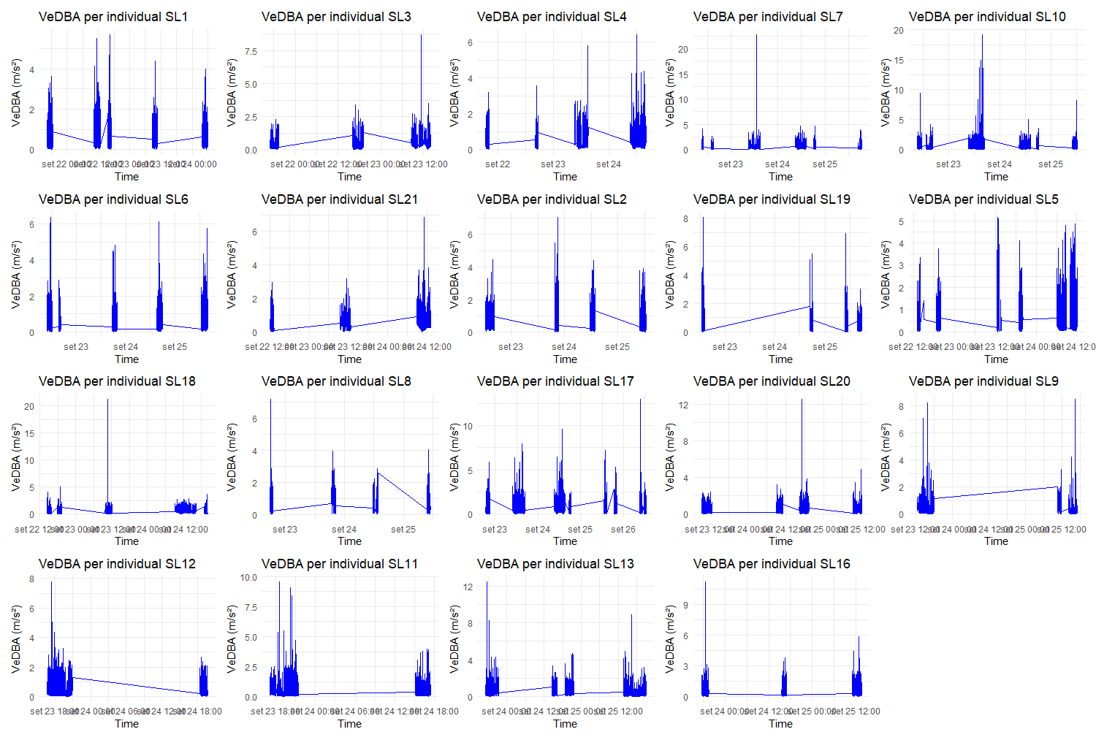

**Figure S1:** Individual Vectorial Dynamic Body Accelerations of brown Boobies from MS.

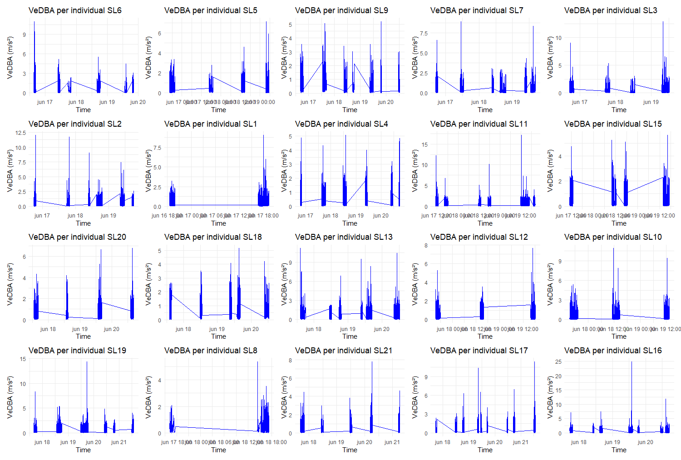

**Figure S2:** Individual Vectorial Dynamic Body Accelerations of brown Boobies from SPSP.

**Figure S3:** Relationship between vectorial dynamic body acceleration (VeDBA) and kilojoules (kJ) as described in the methods proposed by Bennison et al. 2021. The straigh line relationship enables the prediction of kilojoules expended for a given value of VeDBA.